Finance App: What the Project Produces
Nov 11, 2026 · @Amr

At a glance
The Finance App turns a user's bank accounts into one picture of their money: every balance, every transaction sorted into a category, monthly budgets that warn at 80% and 100%, and a dashboard of spending trends. It connects to UK and EU banks through Open Banking, read-only, so it can never move money.
What a user gets, using the demo bank's real figures from testing:
Output | What it shows | Demo example
Accounts overview | Every account across all banks, with a total per currency | 4 accounts at 2 banks: GBP 9,477.57 and EUR 642.10
Transactions | 12 months, synced every 6 hours, never duplicated | 567 transactions, 4 still pending
Categories | Automatic, from 56 built-in rules plus the user's own | Tesco to Groceries, Pret to Eating out, salary to Income
Budgets and alerts | A monthly limit per category, alerts once at 80% and 100% | Eating out: £46.30 of £40.00, over budget
Dashboard | Spending by category this month and a 6-month trend | November: £305.86 across 7 categories
Bank lifecycle | Connect, renew before consent expires, disconnect and delete | Renew banner at 7 days or less
It is a portfolio project: a Python FastAPI backend, PostgreSQL, Redis, a React web app that installs like a phone app, and CI/CD on GitHub. Demos run on a built-in mock bank; the Yapily sandbox adapter is built and awaits credentials.

User journey
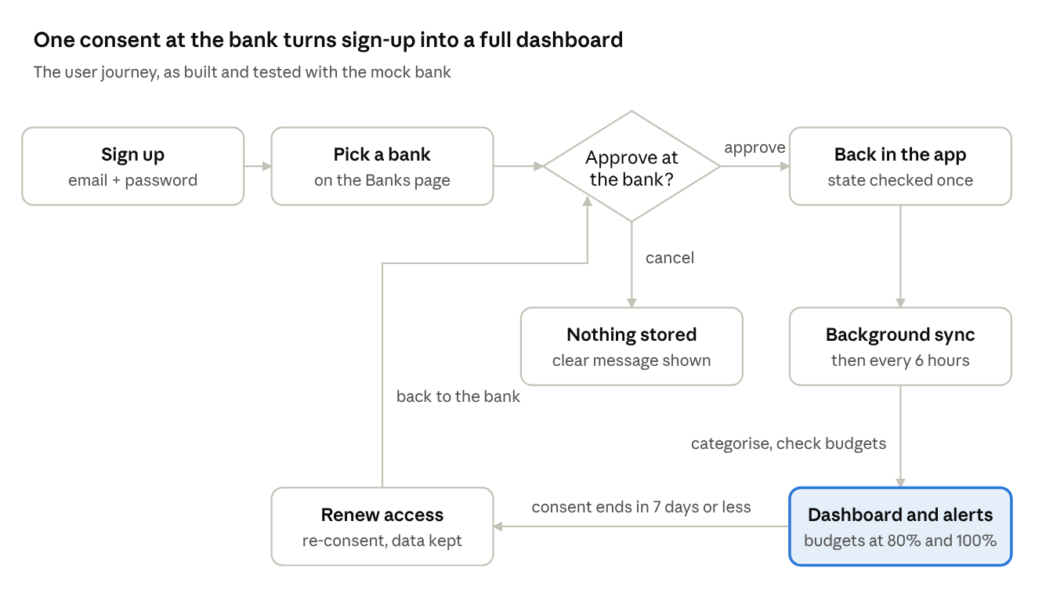
user journey · 7 steps, 1 decision, 1 renewal loop
A user signs up, picks a bank and approves read-only access there; cancelling stores nothing. After approval, a background job fills the dashboard and keeps it current, and a renew banner appears before consent runs out.

Screen sketches
The dashboard answers "where did my money go this month" on one page: alerts first, then totals, categories, the trend and budgets.
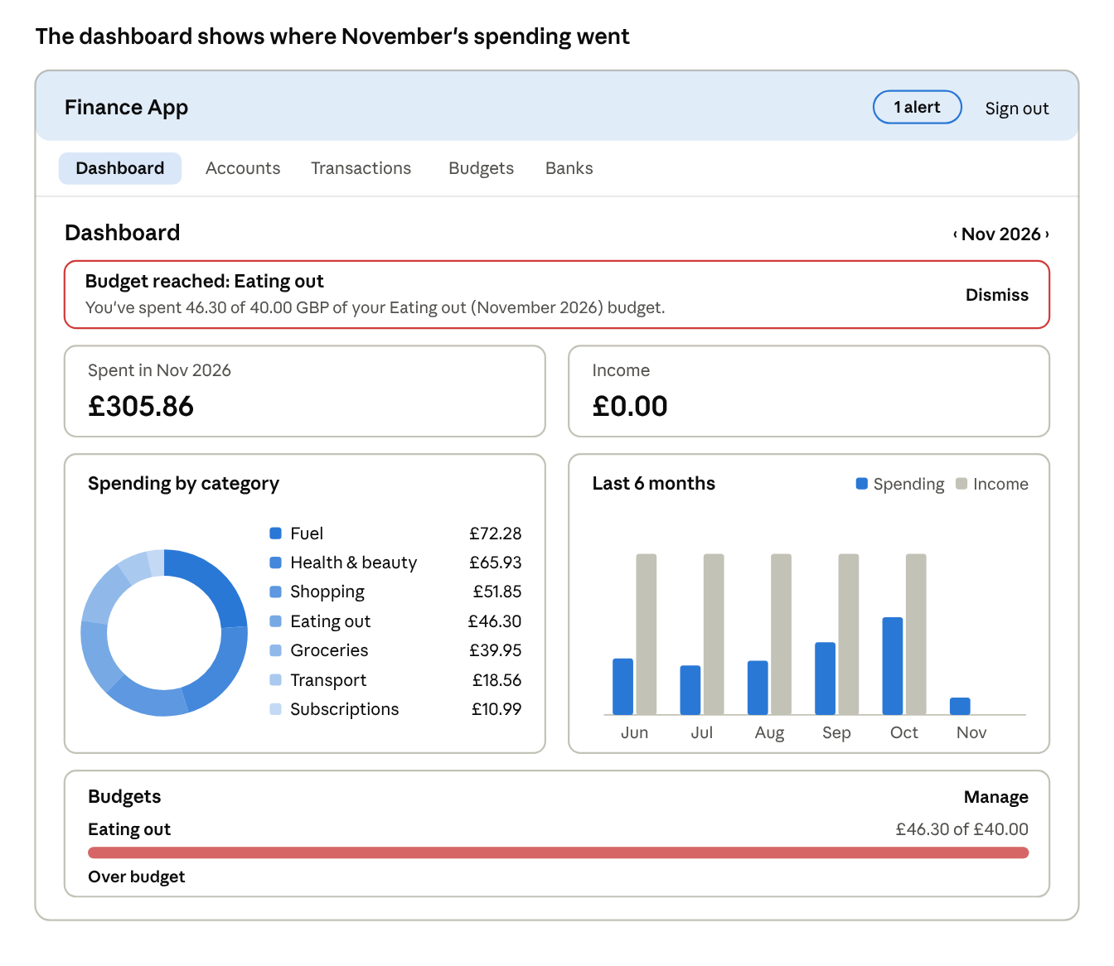
dashboard wireframe · demo figures from the browser test, November 2026
The chart areas carry a text version for screen readers (a list beside the doughnut, a hidden table behind the bars), and the budget states its status in words, not colour alone.
Connecting a bank hands the user to the bank's own page and back. With the mock bank this runs fully offline; with Yapily it is the real bank's page.
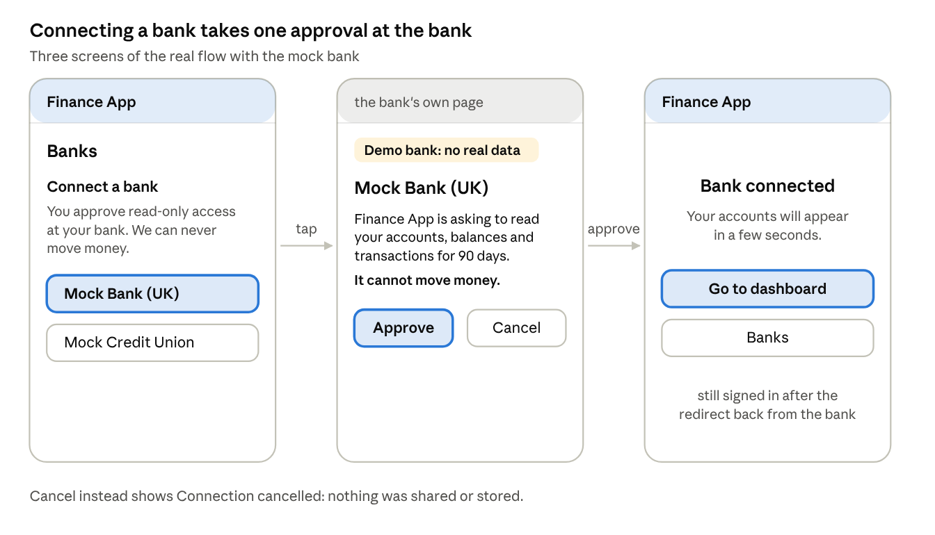
connect-a-bank wireframes · the mock bank flow as tested
Transactions arrive already categorised. Changing one category with "apply to similar" creates a rule that also fixes past and future transactions from that merchant.
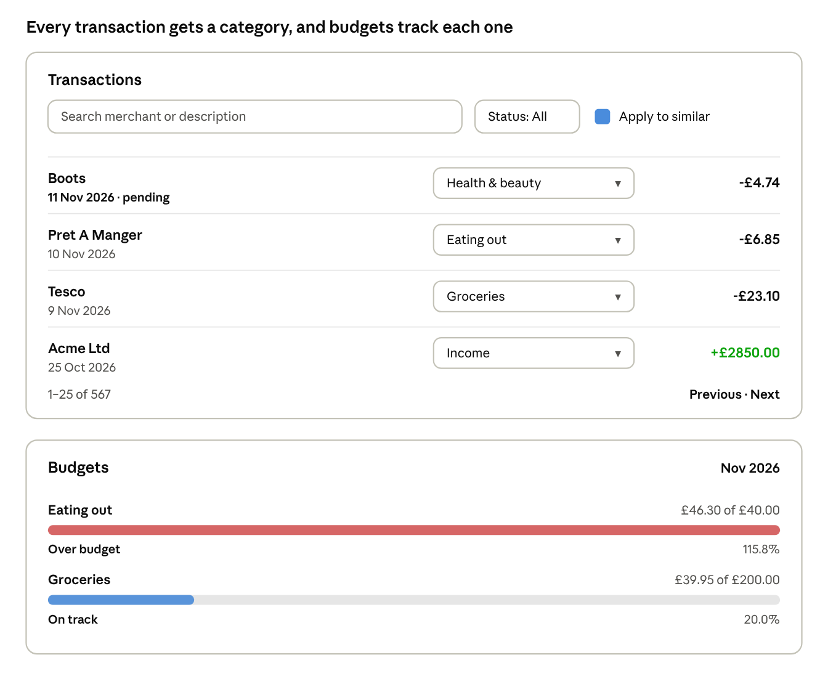
transactions and budgets wireframes · demo rows and budgets from testing

Sample API output
The web app draws every screen from the REST API under /api/v1. Amounts are decimal strings so no pennies are lost, and every currency is kept separate. Responses below are trimmed to one or two items each.
GET /api/v1/accounts: every account and a total per currency (BR-05).
{
"accounts": [
{
"institution_name": "Mock Bank (UK)",
"name": "Everyday Current",
"type": "CURRENT",
"currency": "GBP",
"account_number_masked": "•••• 5555",
"connection_status": "active",
"balance": { "type": "INTERIM_AVAILABLE", "amount": "1523.47", "currency": "GBP" }
}
],
"totals": [
{ "currency": "EUR", "amount": "642.10", "account_count": 1 },
{ "currency": "GBP", "amount": "9477.57", "account_count": 3 }
]
}
GET /api/v1/dashboard/summary?month=2026-11: spending by category and the 6-month trend (BR-11).
{
"month": "2026-11",
"currencies": [
{
"currency": "GBP",
"spending": "305.86",
"income": "0.00",
"by_category": [
{ "name": "Fuel", "amount": "72.28", "share_percent": "23.6" },
{ "name": "Health & beauty", "amount": "65.93", "share_percent": "21.6" }
],
"trend": [
{ "month": "2026-10", "spending": "1729.73", "income": "2850.00" },
{ "month": "2026-11", "spending": "305.86", "income": "0.00" }
]
}
]
}
PUT /api/v1/budgets and the alert it raised (BR-09, BR-10).
{
"category_name": "Eating out",
"month": "2026-11",
"limit_amount": "40.00",
"spent": "46.30",
"remaining": "-6.30",
"percent_used": "115.8",
"status": "exceeded"
}

{
"kind": "budget_exceeded",
"title": "Budget reached: Eating out",
"body": "You've spent 46.30 of 40.00 GBP of your Eating out (November 2026) budget."
}
Errors use one format everywhere (RFC 9457), for example a wrong password:
{ "type": "about:blank", "title": "Unauthorized", "status": 401, "instance": "/api/v1/auth/login", "detail": "Incorrect email or password." }
The full contract is in docs/openapi.json (26 paths) and live at /docs when the API runs.

Behind the scenes
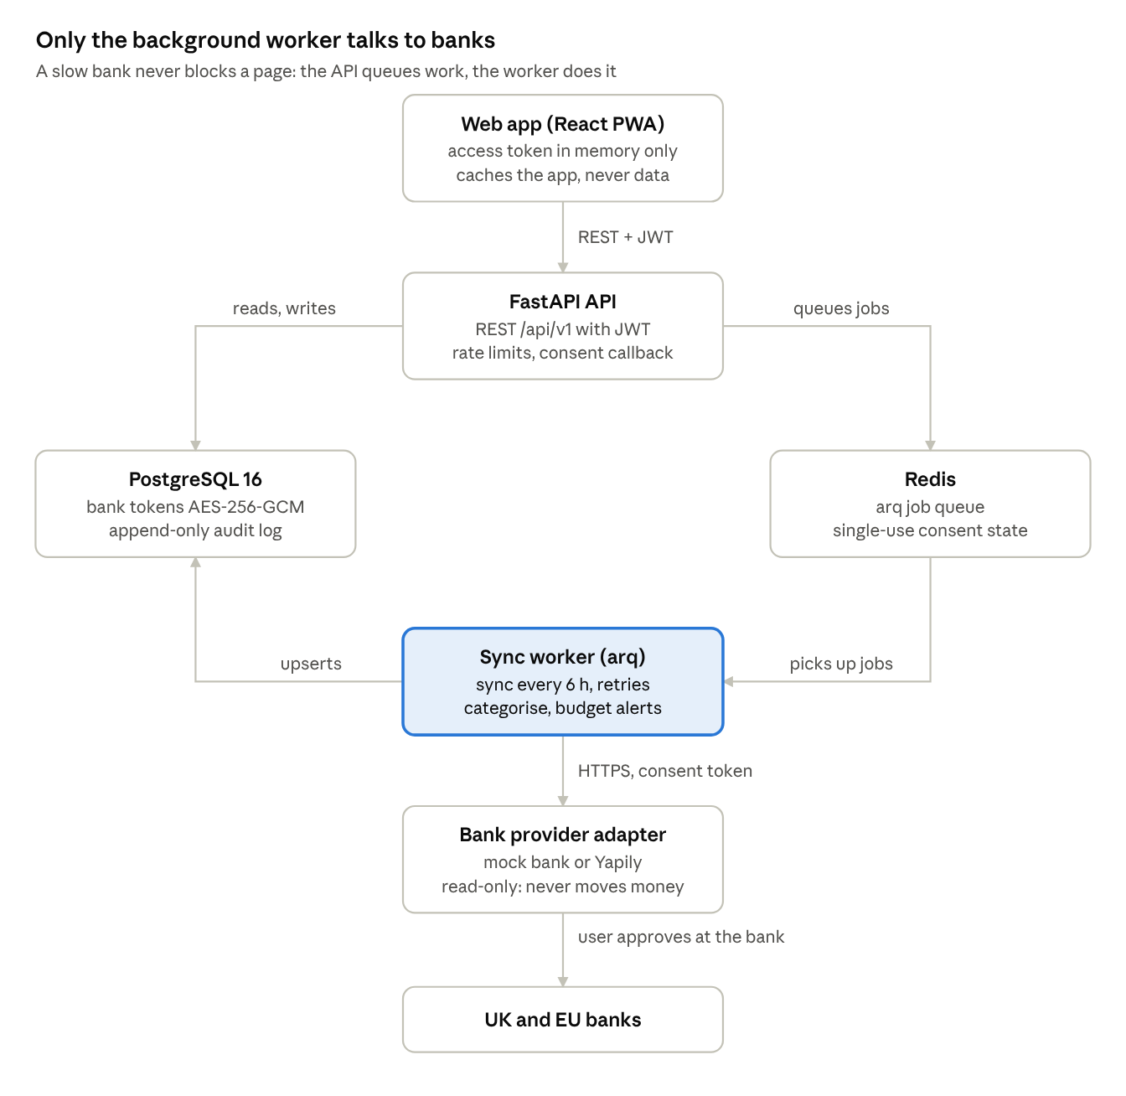
architecture · 7 parts, as built in weeks 1 to 5
Everything runs locally with one docker compose up, which also applies database migrations before the API starts. Every consent, sync and deletion lands in an audit log that the database itself refuses to change.

Status and next
Weeks 1 to 5 of 6 are built and verified: 186 backend tests (90% coverage), 14 web tests, and CI green on every job. The remaining work is deployment and polish.
Week | Delivered | Requirements | Verified
5 | React PWA dashboard, append-only audit log, typed API client | BR-11, NFR-06 | Full journey driven in a browser
4 | Categories, rules engine, budgets, 80/100% alerts | BR-07 to BR-10 | Docker run caught and fixed a Netflix-to-Transport bug
3 | Transaction sync with dedup, renewal, disconnect | BR-03, BR-04, BR-06 | 567 transactions, re-sync adds none
2 | Bank consent flow, mock and Yapily providers, accounts | BR-02, BR-05 | Two banks connected in Docker
1 | Auth with rate limiting, Docker, migrations, CI/CD | BR-01 | Live on GitHub, image published
Still open:
- ☐ Run the Yapily adapter against the real sandbox (needs Yapily credentials)
- ☐ Move the refresh token into an HttpOnly cookie and add a Content-Security-Policy
- ☐ Deploy to AWS (Week 6)
- ☐ README polish, architecture diagram and a demo video under 3 minutes
- ☐ Email alerts, once an email provider is chosen
The step-by-step record of every decision and fix is docs/development-log.md in the repository Najipian/finance-app.

